W02 Learning Activity: HTML Semantic Elements
Overview
HTML describes the structure of a web page. The structure is composed of various categories of elements. Some elements are associated with forms and tabular data. You are not expected to memorize all HTML tags. This course will help you become familiar with the most commonly used elements and then you can refer to others through reliable sources.
Prepare
HTML elements have a specific meaning and are used to structure the content of a web page, but not to style the page. They are used to clearly provide meaning to the browser and developer. Later, once the html structure is in place, you will use styles to adjust the way the page is shown to the user.
Semantic and Non-Semantic HTML Tags
HTML tags can be divided into two main categories: semantic tags and non-semantic tags. Understanding the difference between these types of tags will help you write better web pages that are easier to understand and maintain.
Semantic tags have meaning built into their name. They tell both the browser and other developers what type of content they contain. Non-semantic tags do not have specific meaning about their content. They are used mainly for styling and layout purposes.
What Are Semantic Tags?
Semantic tags describe the meaning and purpose of the content they contain. When you read the tag name, you can understand what kind of information is inside. These tags make your HTML code easier to read and help screen readers assist people with visual impairments.
Common semantic tags include:
- header – Contains introductory content or navigation links
- nav – Contains navigation links to other pages or sections
- main – Contains the main content of the page
- section – Represents a distinct section of content
- article – Contains independent, self-contained content
- aside – Contains content that is related but separate from the main content
- footer – Contains closing information like contact details or copyright
- h1, h2, h3, h4, h5, h6 – Represent different levels of headings
Here is an example of semantic tags used to structure a simple web page:
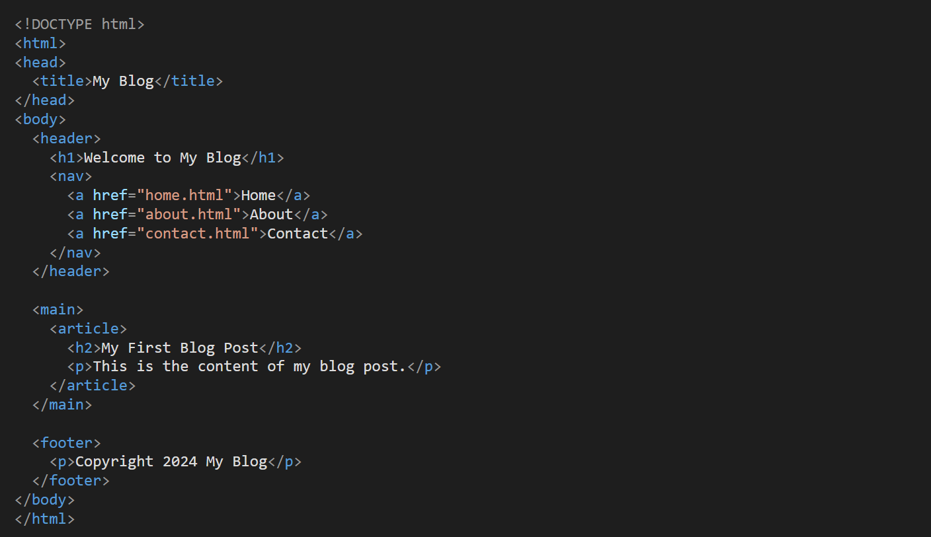
In this example, each tag clearly indicates what type of content it contains. The header contains the site title and navigation, the main section contains the primary content, and the footer contains copyright information.
What Are Non-Semantic Tags?
Non-semantic tags do not provide information about the meaning of their content. They are primarily used for styling and layout purposes. The two most common non-semantic tags are div and span.
Common non-semantic tags include:
- div – A container used for grouping and styling a section of a page
- span – A container used for styling small portions of text
Here is an example showing how non-semantic tags are used:
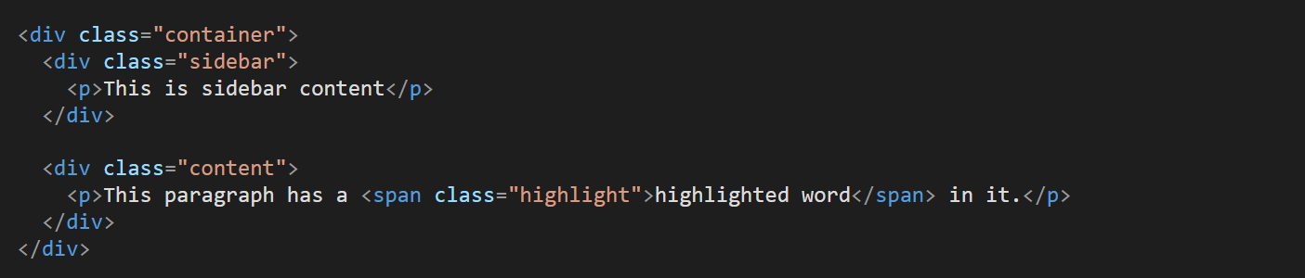
In this example, the div tags are used to create layout sections, and the span tag is used to highlight a specific word. The tags themselves do not tell us what the content represents, but they allow us to apply styling to organize and format the page.
When to Use Each Type
Use semantic tags whenever possible because they make your code more meaningful and accessible. Use semantic tags when the content has a specific purpose or meaning, such as navigation, main content, or article text.
Use non-semantic tags when you need to group elements for styling purposes but the content does not have a specific semantic meaning. For example, use a div to create a colored background area or use a span to change the color of a few words.
Many web sites contain older HTML constructs like <div id="header"> or <div id="navigation">. These older sites are using the generic, non-semantic tags, but try to add meaning through the id. You should not use this approach. Instead, use the semantic HTML tags, <header> or <nav> tags.
Also, because the semantic tags already describe the meaning, you do not need to add extra ids or classes to these tags. Do not use <header id="header"> or <header class="header"> which is unnecessary and redundant.
HTML Heading Tags (h1-h6)
HTML heading tags are used to create titles and section headers on web pages. These tags help organize content and make it easier for users to read and understand your webpage. Search engines also use heading tags to understand the structure and importance of your content.
There are six different heading tags available, numbered from h1 to h6. The h1 tag creates the largest and most important heading, while h6 creates the smallest heading. Think of these tags like an outline for a school report where you have main topics and subtopics.
The Six Heading Tags
- h1 – The main title of your webpage. Use only one h1 tag per page.
- h2 – Major section headings that divide your content into main parts.
- h3 – Subsection headings that break down h2 sections into smaller parts.
- h4 – Minor headings for detailed subsections within h3 sections.
- h5 – Small headings for very specific content areas.
- h6 – The smallest heading, rarely used but available for detailed organization.
How to Use Heading Tags
You should use heading tags in order from largest to smallest. Start with h1 for your main title, then use h2 for major sections, h3 for subsections, and so on. Do not skip heading levels. For example, do not use an h4 directly after an h2 without using h3 first.
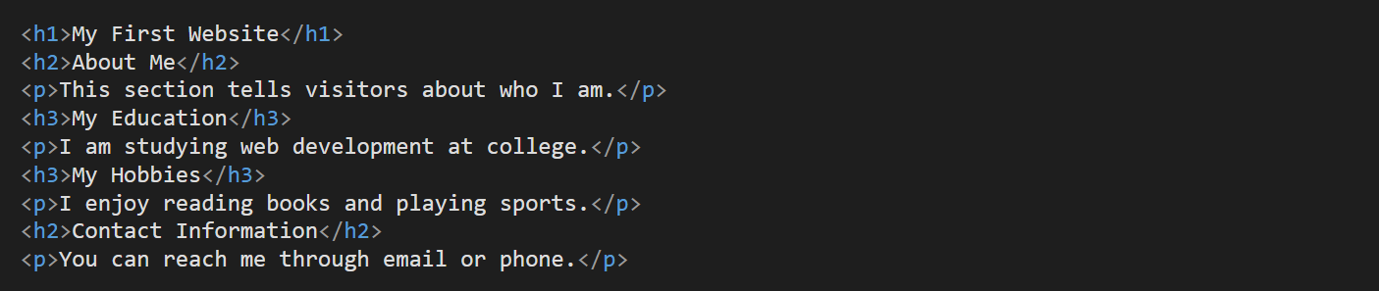
In this example, "My First Website" is the main title using h1. The page is divided into two main sections using h2 tags: "About Me" and "Contact Information." The "About Me" section is further divided into two subsections using h3 tags for "My Education" and "My Hobbies."
Why You Should Not Skip Heading Levels
It is important to use heading tags in the correct order without skipping levels. For example, do not jump from h2 directly to h5 without using h3 and h4 first. Skipping heading levels can cause problems for people who use screen readers to navigate websites. Screen readers are tools that help people with vision problems read web content by speaking it aloud.
When you skip heading levels, screen readers cannot understand the proper structure of your webpage. This makes it difficult for users to jump between sections or understand how your content is organized. Search engines also prefer websites that use proper heading structure because it helps them understand what your content is about. Following the correct heading order makes your website more accessible and easier to find in search

